**Report on Multiple ADC reading in STM32CubeIDE**

1. **System Core:**

* **SYS – Debug: Serial Wire**

1. **Analog:**

* **ADC1 – IN8 & IN9**
* **Continuous Conversion – Enable**

1. **Timers:**

* **Clock Source – Internal Clock**
* **Channel 2 – PWM Generation CH2**
* **Channel 3 – PWM Generation CH3**
* **Prescalar – 127**
* **Counter Period – 625**

1. **Connectivity:**

* **USART1 – Mode – Asynchronous**

1. **Circuit Connection:**

|  |  |
| --- | --- |
| **STM32F103** | **Potentiometer 1**  **Potentiometer 2** |
| **B0, B1** | **POT1 & POT2** |
| **3.3V** | **POT PIN** |
| **GND** | **POT PIN** |

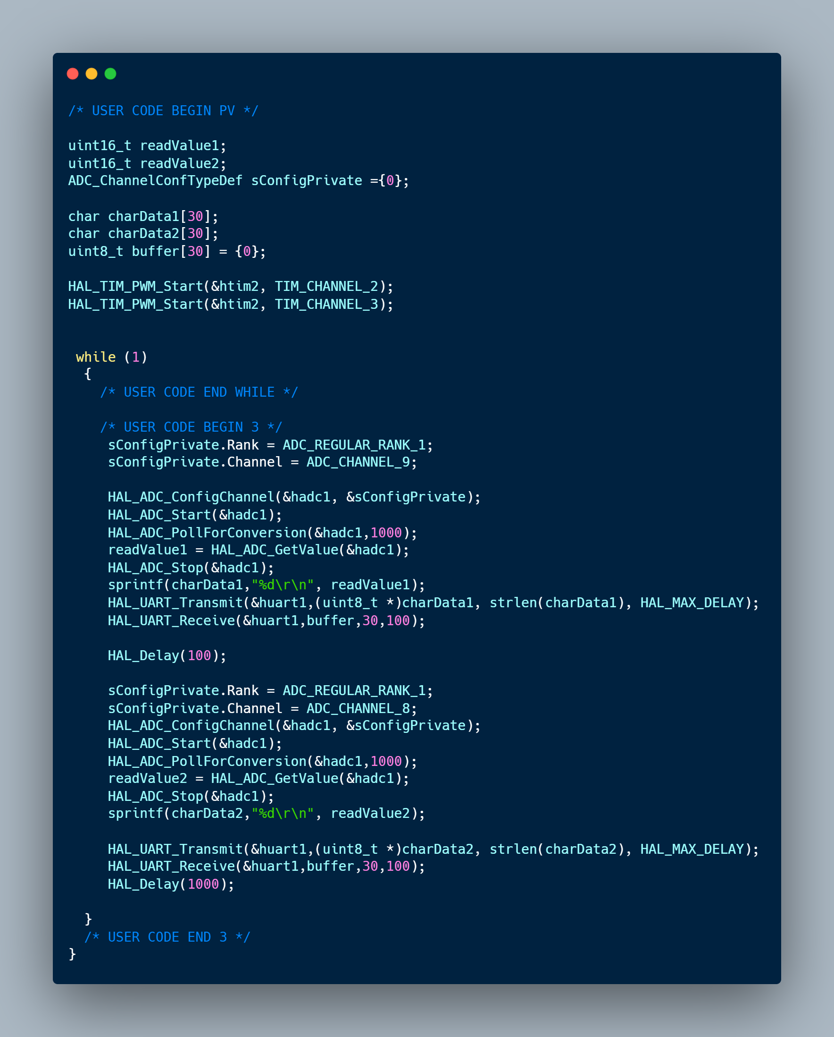

Prepared by : Tanimun Hasan, System Design Engineer, THiNK Limited